Supplementary materials

Accompanying the manuscript “Bright is Not Always Right: Peri-Iridal Brightness Reduces Attractiveness via Perceived Sex-Typicality Across Human Populations”

For the data and the script, please visit: https://github.com/VojtechFiala/EyeProject_Paper_One

## Part 1. Descriptive statistics

The analysis concerned how the colour and tone of human iris and peri-iridal tissues’ colouration affect perceived attractiveness and sextypicality in human faces of various populations. The distribution of the colour and tone within samples was as follows:



**Figure S1**. Violin plots of distribution of Skin (upper row), Iris (middle row), and Scleral (lowermost row) CIELab L* in each population when left (left) on the original scale, (middle) when standardised within each sample, (right) when pooled first and then standardised. Samples, from left to right, in each plot: Cameroon 2013, Cameroon 2016, Colombia, Czech Republic 2016, Czech Republic, 2019, India (CFD), Iran, Turkey, Vietnam. Both sexes together.

**Figure S2**. Violin plots of distribution of Skin (upper row), Iris (middle row), and Scleral (lowermost row) CIELab L*. Women only.

**Figure S3**. Violin plots of distribution of Skin (upper row), Iris (middle row), and Scleral (lowermost row) CIELab L*. Men only.



**Figure S4**. CIELab a*, layout is the same as in Figure S1, except that we only consider iris and scleral a* channel. Both sexes together.

**Figure S5**. CIELab a*, layout is the same as in Figure S1, except that we only consider iris and scleral a* channel. Women.

**Figure S6**. CIELab a*, layout is the same as in Figure S1, except that we only consider iris and scleral a* channel. Men.



**Figure S7**. CIELab b*, layout is the same as in Figure S1 and S2. Both sexes together.

**Figure S8**. CIELab b*, layout is the same as in Figure S1 and S2. Women.

**Figure S9**. CIELab b*, layout is the same as in Figure S1 and S2. Men.

Table S1 describes the raters’ samples descriptive statistics (to be finished).

|  |  |  |  |  |  |  |
| --- | --- | --- | --- | --- | --- | --- |
| **Table S1**. Descriptive statistics of the raters' samples | | | | | | |
| Sample | Sex of the stimuli | Rated Trait | No Raters | Mean Age | SD Age | Inter-rater agreement  (3,k) |
| Cameroon 2013 | Women | Attractiveness | 34 | 22.21 | 3.14 | 0.91 |
|  |  | Femininity | 77 | 24 | 4.123 | 0.91 (CI: 0.88-0.94) |
|  | Men | Attractiveness | 28 | 22.11 | 3.89 | 0.92 |
|  |  | Masculinity | 77 | 24 | 4.123 | 0.95 (CI: 0.94-0.97) |
| Cameroon 2016 | Women | Attractiveness | 49 | 22.96 | 3.23 | 0.96 |
|  |  | Femininity | 94 | 22.99 | 3.00 | 0.97 |
|  | Men | Attractiveness | 51 | 23.37 | 4.25 | 0.96 |
|  |  | Masculinity | 94 | 21.99 | 3.00 | 0.96 |
| Colombia | Women | Attractiveness | 432 | 20.71 | 2.77 | 0.99 (1,k) |
|  |  | Femininity | 432 | 20.71 | 2.77 | 0.99 (1,k) |
|  | Men | Attractiveness | 565 | 21.85 | 4.81 | 0.98 (1,k) |
|  |  | Masculinity | 565 | 21.85 | 4.81 | 0.98 (1,k) |
| Czechia 2016 | Women | Attractiveness | 33 | 28.18 | 4.21 | 0.99 |
|  |  | Femininity | 44 | 30 | 9.683 | 0.97 (CI: 0.96-0.98) |
|  | Men | Attractiveness | 89 | 27.56 | 4.23 | 0.99 |
|  |  | Masculinity | 231 | 32.039 | 7.595 | 0.99 (CI: 0.99-1.00) |
| Czechia 2019 | Women | Attractiveness | 35 | 31.89 | 6.80 | 0.95 (CI: 0.93-0.97) |
|  |  | Femininity | 60 | 34.3 | 9.206 | 0.97 (CI: 0.96-0.98) |
|  | Men | Attractiveness | 76 | 32.43 | 9.61 | 0.97 (CI: 0.96-0.98) |
|  |  | Masculinity | 63 | 34.079 | 8.977 | 0.97 (CI: 0.96-0.98) |
| India | Women | Attractiveness | 33.8* | 33.51 | 8.48 | NA |
|  |  | Femininity | 33.8* | 33.51 | 8.48 | NA |
|  | Men | Attractiveness | 19.5* | 33.51 | 8.48 | NA |
|  |  | Masculinity | 19.5* | 33.51 | 8.48 | NA |
| Iran | Women | Attractiveness | 46 | 37.3 | 12.29 | 0.93 |
|  |  | Femininity | 33 | 27.73 | 3.77 | 0.92 |
|  | Men | Attractiveness | 41 | 34.88 | 9.91 | 0.9 |
|  |  | Masculinity | 31 | 29.35 | 4.54 | 0.93 |
| Turkey | Women | Attractiveness | 1207 | 22.09 | 3.66 | 0.96 (1,k) |
|  |  | Femininity | 1207 | 22.09 | 3.66 | 0.95 (1,k) |
|  | Men | Attractiveness | 1207 | 22.09 | 3.66 | 0.95 (1,k) |
|  |  | Masculinity | 1207 | 22.09 | 3.66 | 0.94 (1,k) |
| Vietnam | Women | Attractiveness | 86 | 22.2 | 3.76 | 0.96 (3,k) |
|  |  | Femininity | NA | NA | NA | NA |
|  | Men | Attractiveness | 124 | 22.96 | 4.26 | 0.976 (3,k) |
|  |  | Masculinity | NA | NA | NA | NA |
| *Average No. Of raters per face (878 [238 Females] fulfilled the authors criteria (Ma et al., 2021) to be included. | | | | | | |

## Part 2. Alternative analyses #1: Standardised separately

### 2.1. Standardised separately, full analysis.

<Script: 5_Standardised Separately Full Analyses> &  
<Script: 6_Visualisation_Standardised_Separately_Analogue_of_the_Main_Figures>

<Model 3 = Attractiveness>  
<Model 4 = SexTypicality>

Alternative setup, data are standardised separately in each sample. This way the information on relative variance between different samples is not preserved. Absolute size of the estimated associations should better represent how important is the available variance for the within-population raters. See the right table in Figures S1-9 to fully recognise the consequences on the variance (both within and across samples) in the data.

**Figure S10**. Perceived attractiveness in women (left half), and men (right half) of the Figure, predicted by iris and scleral colour (left/right – in each sex) L*, a*, and b* (upper, middle, lower panel). All the variables were standardised separately (standardisation within each sample). See Figures 3-4 in the main article for a comparison. Basically, the associations mostly follow the same pattern but are somehow weaker. This is a consequence of standardising separately: different within-culture ranges of iris and peri-iridal tissues’ L*a*b*, when weighted equally, lowers the strength of the association. It is a consequence of a probable lower importance of a relatively invariant trait. The global effect is not allowed to “learn more” from the more pronounced effect in more variable populations. This is not a mistake; it is a consequence of different treatment of the data. Instead of saying: this would be the global effect if the populations were relatively highly variable, the plot shows the global effect and the per-culture effect when the model expect low and high variance to have similar effect on the perceivers from the given culture.



**Figure S11**. Perceived sextypicality, all variables were standardised across cultures. The layout is the same as in Figure S10.

### 2.2. Standardised together, analysis without Iranian sample.

The Iranian women were photographed and rated when wearing hijab, a piece of clothing that covers the hair and may cover the edge of the mandible. This may impair the shape analyses, as the semilandmarks denoting this edge may be laid less precisely. Running the analysis without Iranians present a remedy to eventual artifacts of the eventual mistakes during image landmarking. We did not rerun the analyses in Script “1_Calculating_Morphometrics.R” again, without Iranians. The geomorph data frame does rely on the TPS data that were aligned globally (gpa across all the data), but the subsequent steps treat each culture separately.

<Script: 8_Visualisation_standardised together_without_Iranians_without_skin_L.R>

<Model 9 = Attractiveness, without Iranians>  
<Model 10 = SexTypicality, without Iranians>

**Figure S12**. Perceived attractiveness in women (left half), and men (right half) of the Figure, predicted by iris and scleral colour (left/right – in each sex) L*, a*, and b* (upper, middle, lower panel). All the variables were standardised together (standardisation across all the samples). The Figure does not contain Iranians; there were no Iranians in this analysis.

**Figure S13**. Perceived sextypicality in women (left half), and men (right half) of the Figure, predicted by iris and scleral colour (left/right – in each sex) L*, a*, and b* (upper, middle, lower panel). All the variables were standardised together (standardisation across all the samples). Again – done without the Iranian sample.

### 2.3. Standardised together, analysis without considering skin L* as a predictor.

Lightness (L*) of the skin is an important predictor of facial characteristics, at least in some cultures (Fiala et al., 2021, Pokorný et al. 2024). Including or excluding this measure may affect the results. In case the effects are reverted, it may render the results of the main analysis unreliable. If the results persists mostly as they originally were, they confirm the effects of eye colour are robust.

<Script: 8_Visualisation_standardised together_without_Iranians_without_skin_L.R>

<Model 11 = Attractiveness>  
<Model 12 = SexTypicality>

**Figure S14**. Perceived attractiveness in women (left half), and men (right half) of the Figure, predicted by iris and scleral colour (left/right – in each sex) L*, a*, and b* (upper, middle, lower panel). All the variables were standardised together (standardisation across all the samples). A version of the model without skin L*.



**Figure S15**. Perceived sextypicality in women (left half), and men (right half) of the Figure, predicted by iris and scleral colour (left/right – in each sex) L*, a*, and b* (upper, middle, lower panel). All the variables were standardised together (standardisation across all the samples). A version of the model without skin L*.

While some of the associations become less pronounced or their estimation worsened, the overall patter is, again, preserved. Therefore, we conclude that including facial L* in the analysis is important as it affects the results substantially; however, the effect of eye morphology is present even when skin lightness is not in the analysis.

[To podtim budu dělat jen pokud by ti to chybělo. Musim bejt línější, říkal jsi; vše ostatní bude v coeftabech – pak mi nedává smysl je tady opakovat.]

## Part 3. Bayesian path analyses

### 3.1. Women:

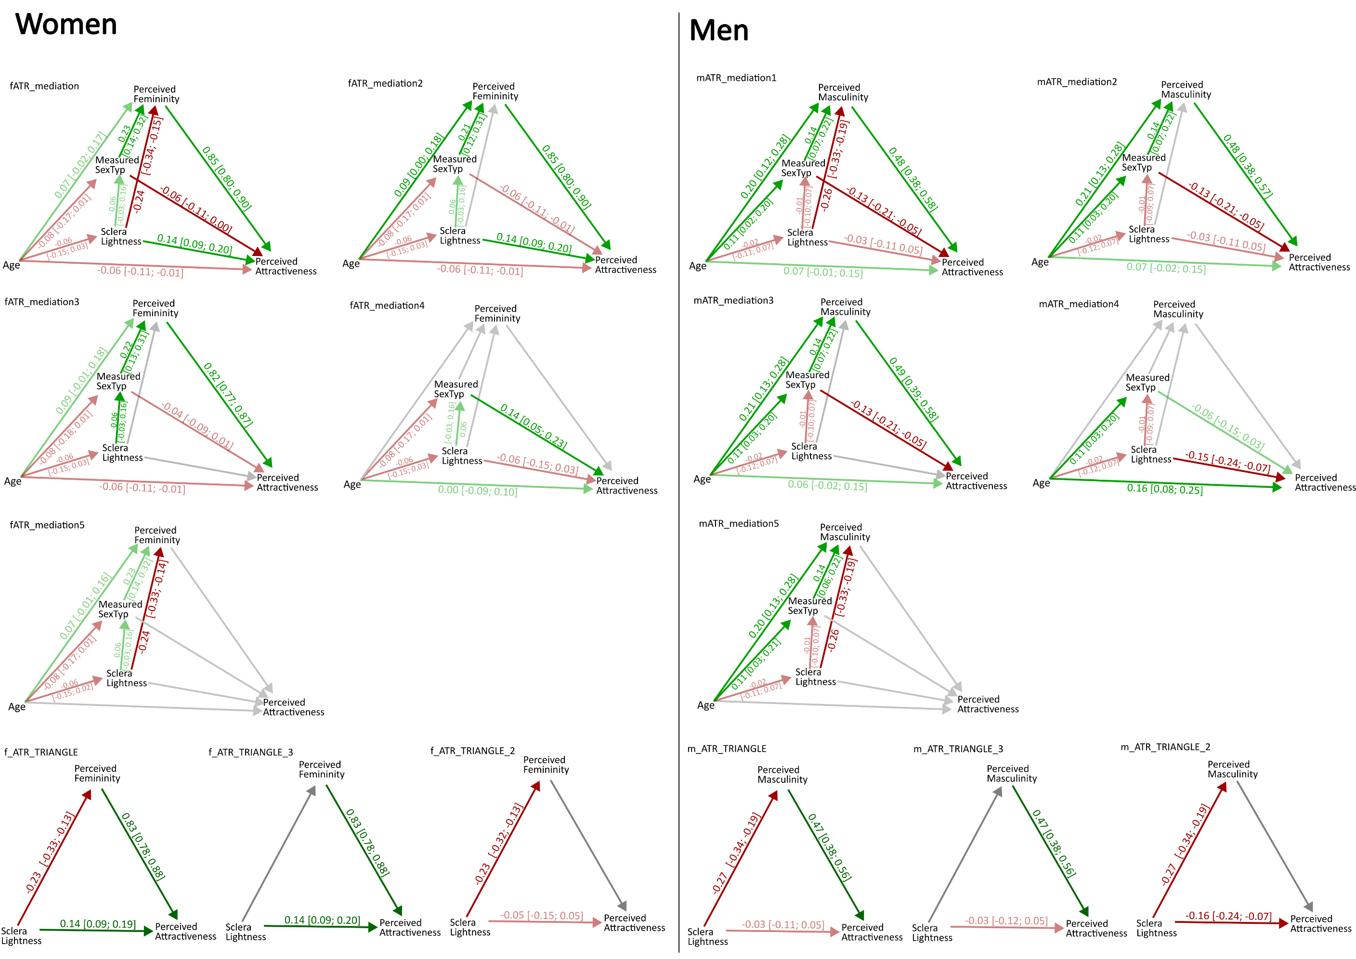

**Figure S15**. Bayesian path analyses. Women. Extended version of Figure 4 from the article.

### 3.2. Men

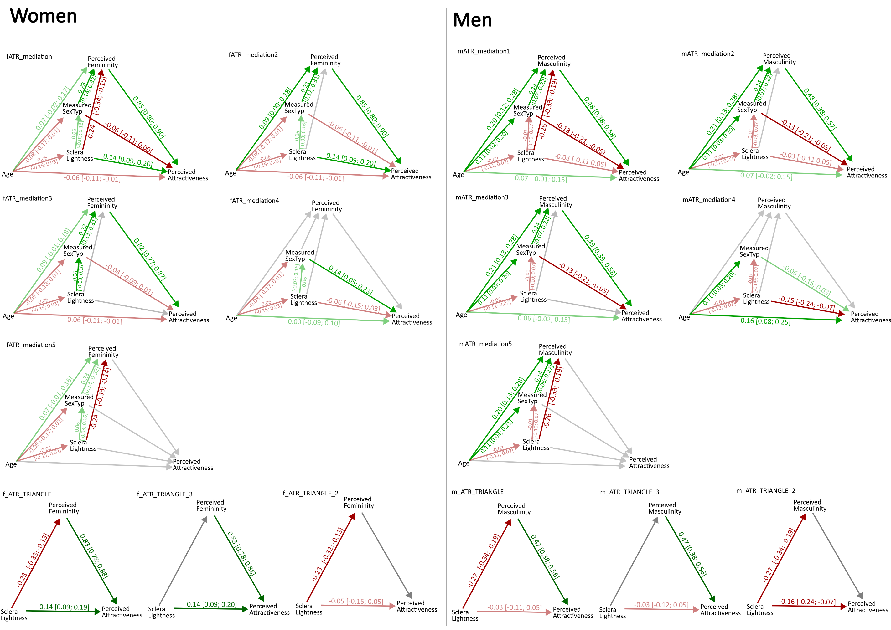

**Figure S16**. Bayesian path analyses. Men. Extended version of Figure 4 from the article.

## 3.3. Path Analyses per culture:

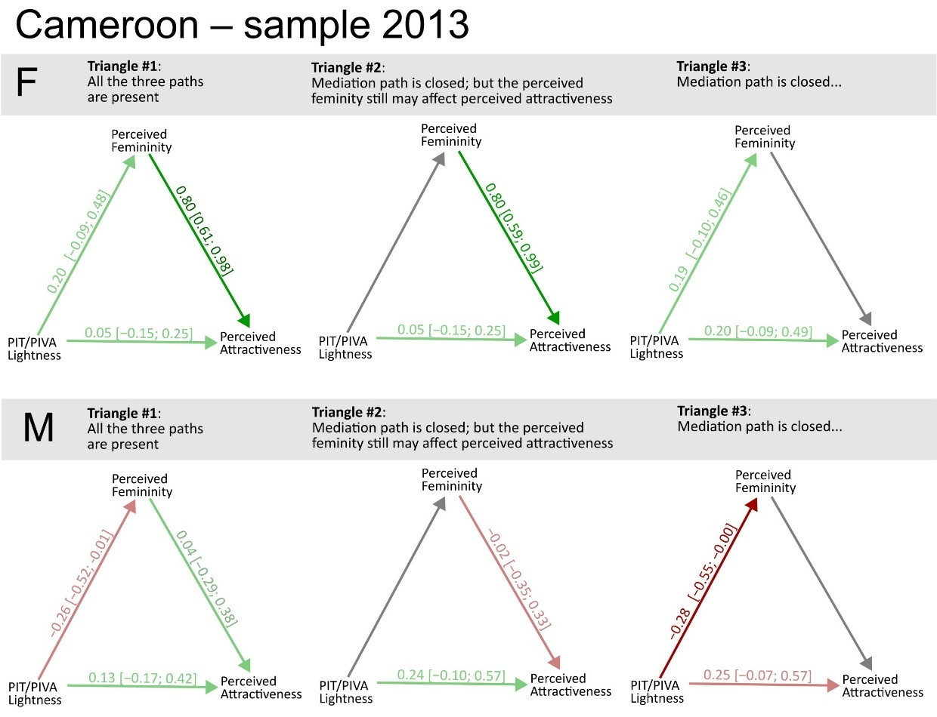

**Figure S17**. Path analyses – Cameroon, 2013 sample. PIT/PIVA ~ peri-iridal tissues lightness.

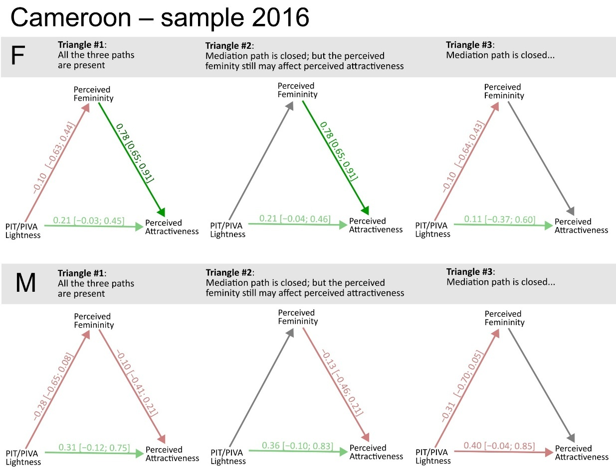

**Figure S18**. Path analyses – Cameroon, 2016 sample

Obsah obrázku text, diagram, řada/pruh, Vykreslený graf

Obsah vygenerovaný umělou inteligencí může být nesprávný.

**Figure S19**. Path analyses – Colombian sample

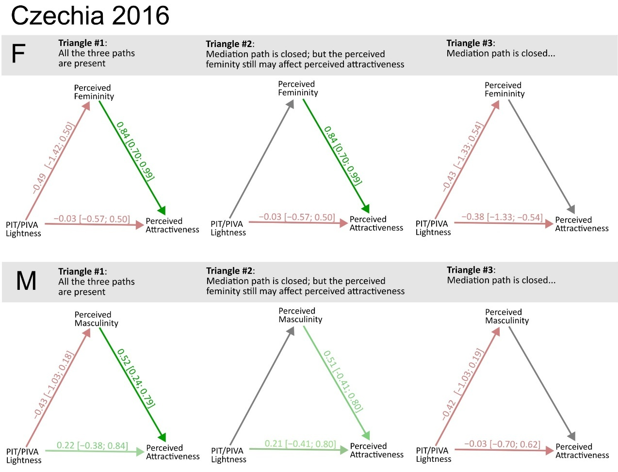

**Figure S20**. Czechia, sample 2016. Please note the massively bevidened credible intervals.

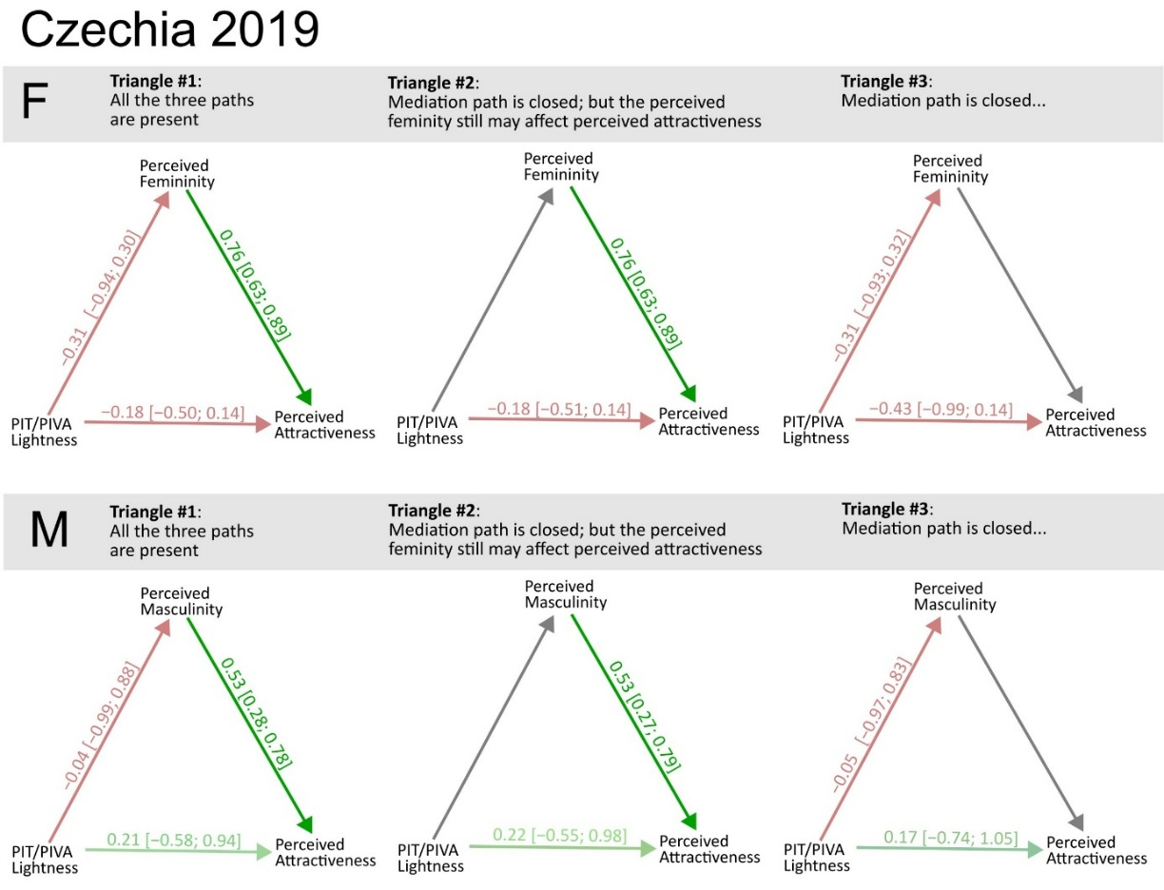

**Figure S21**. Czechia, sample 2019. Please note the massively bevidened credible intervals.

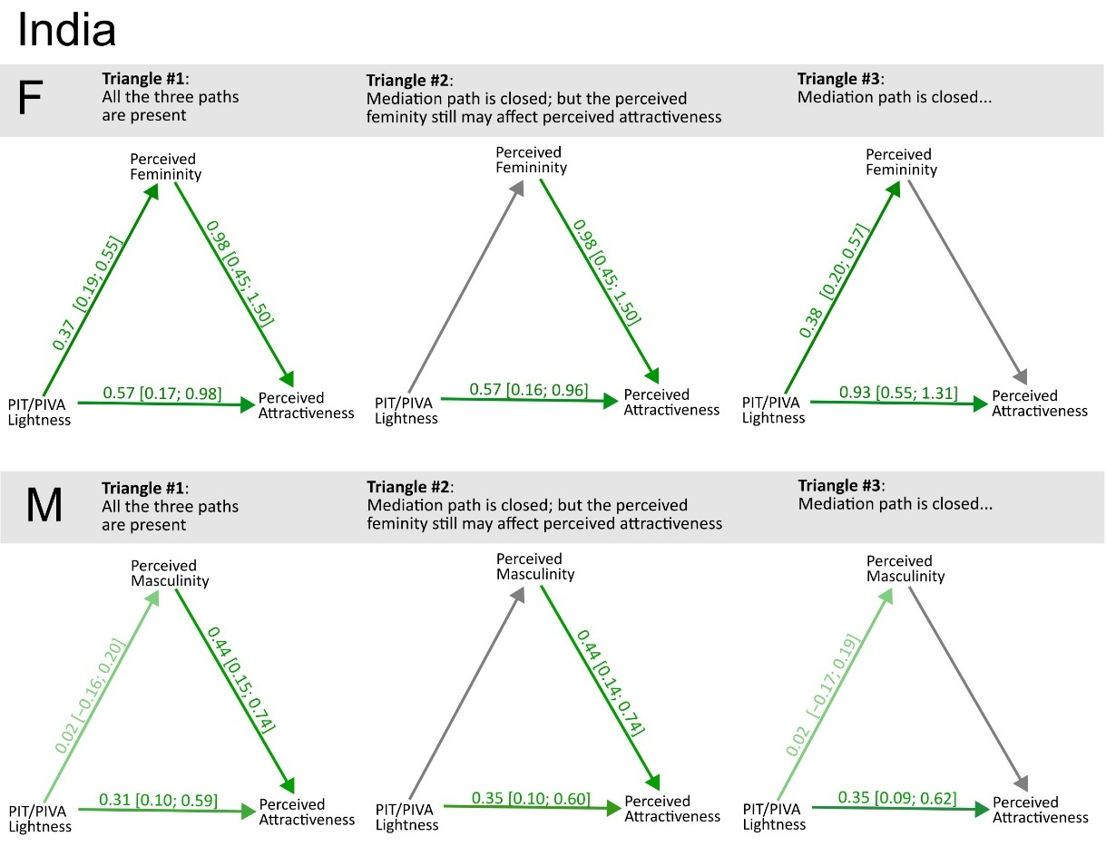

**Figure S22**. India.

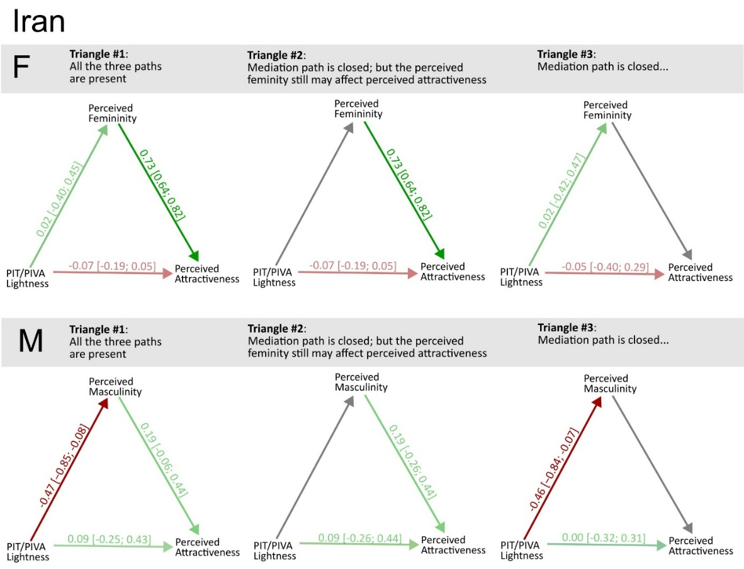

**Figure S23**. Iran.

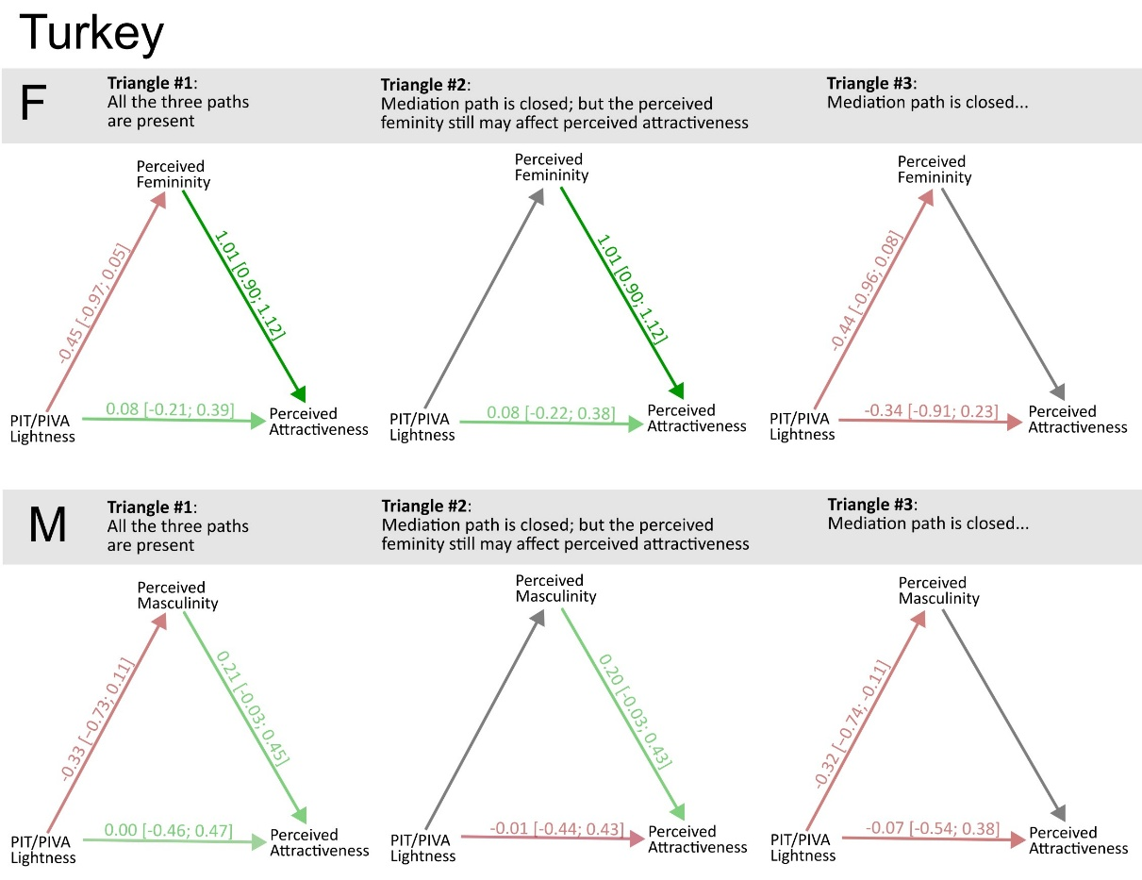

**Figure S24**. Turkey

## 4. Reference

Fiala, V., Třebický, V., Pazhoohi, F., Leongómez, J. D., Tureček, P., Saribay, S. A., Akoko, R. M., & Kleisner, K. (2021). Facial attractiveness and preference of sexual dimorphism: A comparison across five populations. *Evolutionary Human Sciences*, *3*. https://doi.org/10.1017/ehs.2021.33

Pokorný, Š., Pavlovič, O., & Kleisner, K. (2024). Sexual Dimorphism: The Interrelation of Shape and Color. *Archives of Sexual Behavior*, *53*(8), 3255–3265. https://doi.org/10.1007/s10508-024-02918-1